Question 1

Part 1 (a)

def Unknown(x, y):

    if x < y:

        print(x+y)

        return (Unknown(x+1, y)\*2)

    else:

        if y == x:

            return 1

        else:

            print(x+y)

            return (Unknown(x-1, y)//2)

part 1(b)(i)

print("10 and 15")

print(Unknown(10, 15))

print("10 and 10")

print(Unknown(10, 10))

print("15 and 10")

print(Unknown(15, 10))

part 1(b)(ii)

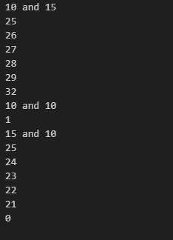

Part 1 (c)

def IterativeUnknown(x,y):

    Total = 1

    while x != y:

        print(f'{str(x + y)}')

        if x < y:

            x+=1

            Total =  Total\*2

        else:

            x-=1

            Total =  Total//2

    return Total

part 1(d)(i)

print("10 and 15")

print(IterativeUnknown(10, 15))

print("10 and 10")

print(IterativeUnknown(10, 10))

print("15 and 10")

print(IterativeUnknown(15, 10))

part 1(d)(ii)

